# Tesla Stock Price Analysis Using Technical Indicators and Machine Learning

**Abstract**

This project explores Tesla stock data over several years to identify patterns, trends, and build a machine learning model to predict short-term price direction. Using technical indicators like RSI, MACD, and Moving Averages, we trained and evaluated a binary classification model to forecast whether the stock would go up or down the next trading day. The model's performance was assessed using metrics such as accuracy and ROC-AUC, and feature importance was analyzed to understand the predictive power of each input. Limitations and future directions are also discussed.

**Objective**

* To explore Tesla stock’s behavior over time through visualizations and descriptive statistics.
* To build a model that predicts if Tesla's stock price will go up or down the next day.
* To extract insights from technical indicators that could aid in understanding market behavior.
* To evaluate the model's effectiveness using real-world data.

**Data Sources**

* The data was obtained from Kaggle’s Tesla stock dataset, covering 3680 trading days.
* Attributes include Open, High, Low, Close, Adj Close, and Volume.
* Open: The price at which a stock first trades when the market opens on a given day.
* High: A stock's highest price during the trading day.
* Low: A stock’s lowest price during the trading day.
* Close: The final price at which a stock trades before the market closes for the day.
* Adjusted Close: Closing price adjusted for corporate actions, essential for accurate long-term stock analysis."
* Volume: The total number of shares of a stock that were traded during the trading day indicates the trading activity level.

All the attribute values are quantitative.

**Exploratory Data Analysis (EDA)**

## Open

|  |
| --- |
| count 3680.000000 |
| mean 83.922418 |
| Std 110.691512 |
| min 1.076000 |
| 25% 12.229167 |
| 50% 18.169334 |
| 75% 181.850002 |
| max 475.899994 |
| Median 97.30696478135337 |

Over 3680 trading days, the average (mean) opening price of the stock was 83.922418. The standard deviation was 110.691512, indicating high variability relative to the mean. The lowest opening price recorded was 1.076000. The 25th percentile was 12.229167, meaning 25% of the opening prices were below this value. The median opening price was 18.169334, indicating that 50% of the opening prices were below this value. The significant difference between the mean and median suggests a positively skewed distribution. The 75th percentile was 181.850002, meaning 75% of the opening prices were below this value. The highest opening price was 475.899994, giving a price range of 1.076000 to 475.899994. For open, the difference between Median and outlier has a huge difference, which strongly suggest a right-skewed distribution due to these high outlier.

The box plot shows the distribution of Tesla's opening prices, with a median around $97. The wide box (IQR: $15 to $185) indicates significant price variability. The longer upper whisker and outliers above $435 reveal a **right-skewed distribution**, meaning occasional but significant jumps in opening price. These outliers likely reflect impactful market events or company news. While $97 represents a typical opening price, the plot highlights Tesla's volatile nature at market open, with several instances of considerably higher prices.

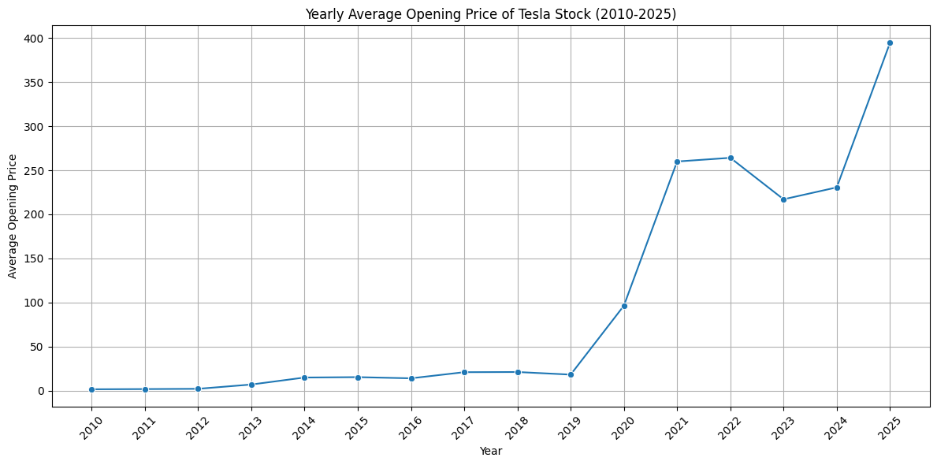

**Yearly Average Opening Price of Tesla Stock (2010-2025)**

* **Insight:** This line graph shows a relatively stable, low average opening price from 2010 to 2019, generally staying below $20. A significant jump occurs in 2020, followed by a plateau in 2021-2022 around $260. There's a slight dip in 2023, a recovery in 2024, and then an explosive surge in 2025, reaching nearly $400.

For nearly a decade, Tesla's stock had traded quietly, positioning the company as a nascent player in the automotive world. Investors who bought in before 2020 saw minimal immediate returns. Then, 2020 hit like an electric shockwave. The company, perhaps benefiting from increased focus on EVs during the pandemic or specific strategic moves, saw its average opening price skyrocket. This rapid growth continued, solidifying its position above $250, before experiencing a minor correction in 2023. However, in 2025, after the US election, marked an incredible resurgence, pushing the stock to unprecedented heights, suggesting a renewed wave of optimism or significant company milestones.

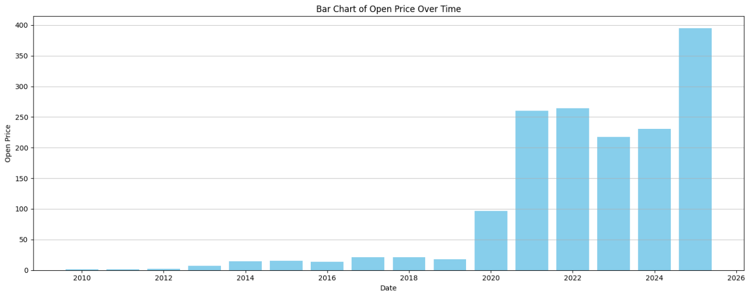

**Bar Chart of Open Price Over Time**

* **Insight:** This bar chart visually reinforces the dramatic shift in Tesla's average open price. It clearly shows the extended period of very low prices from 2010 to 2019, followed by the towering bars from 2020 onwards, with 2025 being the highest bar by a significant margin.

This chart provides a stark visual narrative of Tesla's journey from a niche investment to a Wall Street titan. The nearly invisible bars of the early years represent a period where the company was building its foundation, largely unnoticed by the broader market in terms of significant stock appreciation. Then, from 2020, the bars become colossal, reflecting the market's sudden and aggressive valuation of Tesla, culminating in 2025,

**Yearly Average Closing Price of Tesla Stock (2010-2025)**

* **Insight:** This graph mirrors the opening price graph almost exactly. The average closing price remains low until 2019, then experiences a sharp rise in 2020, stabilizes in 2021-2022, dips in 2023, recovers in 2024, and surges in 2025 to nearly $400.

The similarity between the opening and closing price charts indicates consistent market behavior throughout the trading day, on average. It reinforces the story of slow, steady growth in the early years, followed by the monumental 2020. The close alignment of opening and closing price averages shows that changes weren't just random daily fluctuations. Instead, they represented genuine shifts in how the market valued Tesla from the beginning to the end of each trading period over the years. The strong finish in 2025's average closing price highlights continued positive investor sentiment.

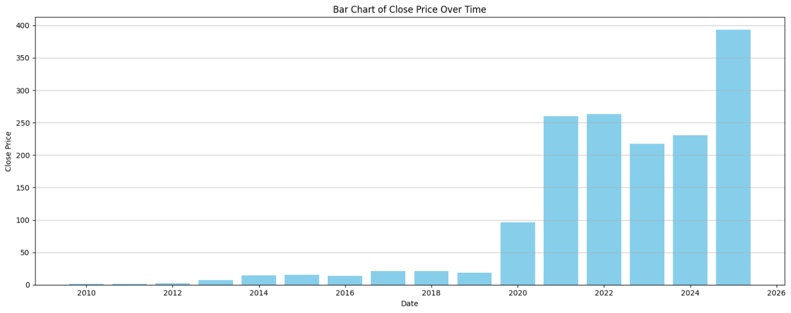

**Bar Chart of Close Price Over Time**

* Insight: This bar chart visually confirms the sustained low closing prices before 2020 and the explosive growth afterward. The 2025 bar represents the highest average closing price.

This bar chart reiterates the dramatic transformation. The "pre-2020" era appears almost flat, depicting Tesla as a long-term hold for those with foresight. Post-2020, the chart erupts into towering columns, vividly illustrating the new reality of Tesla as a high-value stock. The ultimate height of the 2025 bar speaks volumes about its remarkable ascent and sustained investor confidence, ending each year on a high note, reflecting collective optimism.

**Yearly Average Volume of Tesla Stock (2010-2025)**

* Insight: The trading volume shows early fluctuations, peaking in 2013 and then experiencing a massive surge in 2020, reaching over 2.2 billion units. Post-2020, the volume has generally declined, though remaining significantly higher than pre-2020 levels, with a notable increase in 2023.

While the stock's price remained steady in its early years, there was a noticeable increase in **trading activity** in **2013**. However, **2020** was a standout year, marked by a massive surge in **trading volume** and significant market excitement. In 2020, Tesla launched the Model Y, a compact SUV, which is expected to become one of its best-selling models. Tesla's inclusion in the S&P 500 index in December 2020 was also a major event, further boosting investor confidence and signaling its growing importance in the automotive industry. In 2020, Tesla achieved a full-year profit for the first time. This indicated a huge spike in **investor interest**. Although this intense activity decreased in later years, the stock still saw much higher trading volumes than in its initial period. A rise in trading in **2023** suggests renewed investor engagement, possibly linked to a recent price dip and recovery.

**Bar Chart of Close Price Over Time**

* Insight: This graph is a bar chart of the *volume* **Close Price.** It confirms the massive volume spike in 2020, and then subsequent lower but still elevated volumes compared to the pre-2020 period. The uptick in 2023 volume is also clearly visible.

If we assume this represents volume this chart provides a powerful visual on market activity. The "wall" of trading in 2020 stands out, signifying the point where Tesla became a household name in investment circles. After this peak, even though the intense excitement cooled down a bit, the consistently higher bars compared to before 2020 show that Tesla remained a very liquid and actively traded stock. This reflects ongoing, though less frantic, market participation. The 2023 spike underscores that even after the initial boom, significant events or shifts could still trigger bursts of trading.

**Yearly Average Stock Prices (2010-2025) - Open, High, Low, Close, Adj Close**

* Insight: This line graph shows all average yearly stock prices (Open, High, Low, Close, Adjusted Close) tracking each other extremely closely. The pattern is identical to the individual open and close price charts: low until 2019, massive jump in 2020, plateau/correction 2021-2024, and a final surge in 2025.

This composite chart provides the overarching narrative: the entire spectrum of Tesla's stock performance moves in lockstep. The tight clustering of the Open, High, Low, Close, and Adjusted Close lines demonstrates remarkable consistency in average yearly valuations across these metrics. This reinforces that the dramatic shifts observed were not just about a specific point in the day but a wholesale re-evaluation of Tesla's worth by the market. The uniformity of the lines, particularly during the 2020 surge and the 2025 acceleration, indicates strong, consensus-driven market sentiment around Tesla's value. The journey from near-zero averages to nearly $400 average yearly prices paint a picture of exceptional, consistent, and broad-based growth.

In this chart, the massive price appreciation from late 2019 was directly paralleled by an unprecedented increase in trading volume, confirming that the stock's revaluation was driven by widespread, intense market participation.

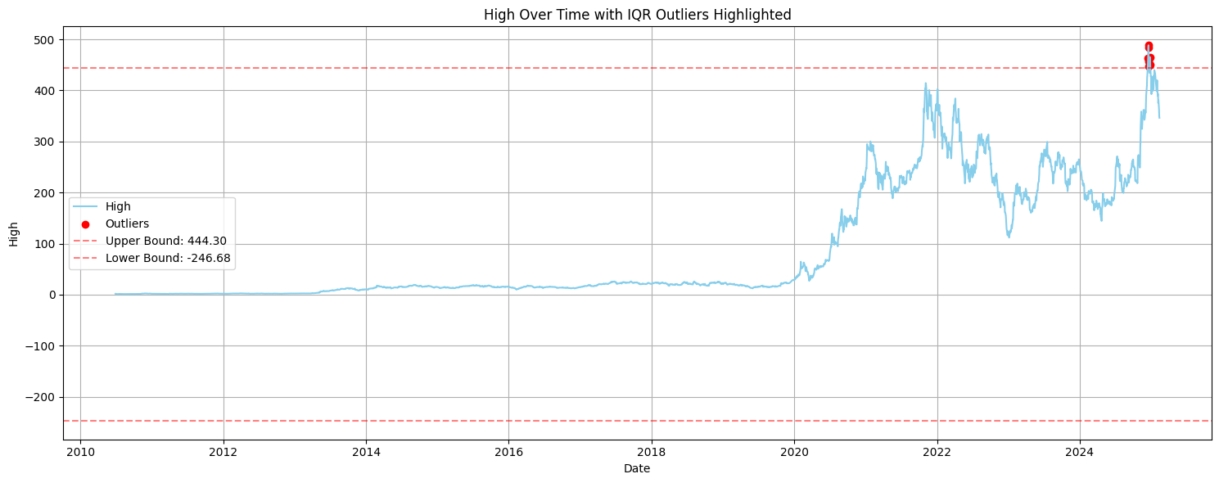In this chart, Tesla's daily peak prices show an aggressive upward trajectory since late 2019, with the most recent period reaching outlier highs, reflecting strong daily buying pressure and increasing market optimism about the stock's potential.

In this chart, Even the lowest daily trading prices for Tesla have been re-rated dramatically upwards since late 2019, confirming a strong underlying upward trend in market valuation, with recent lows themselves being outlier highs compared to historical data.

In this chart, the stock's closing price, a key indicator of daily market sentiment, transformed from stagnant to highly volatile and trending upwards from late 2019, with recent closes hitting new statistical highs.

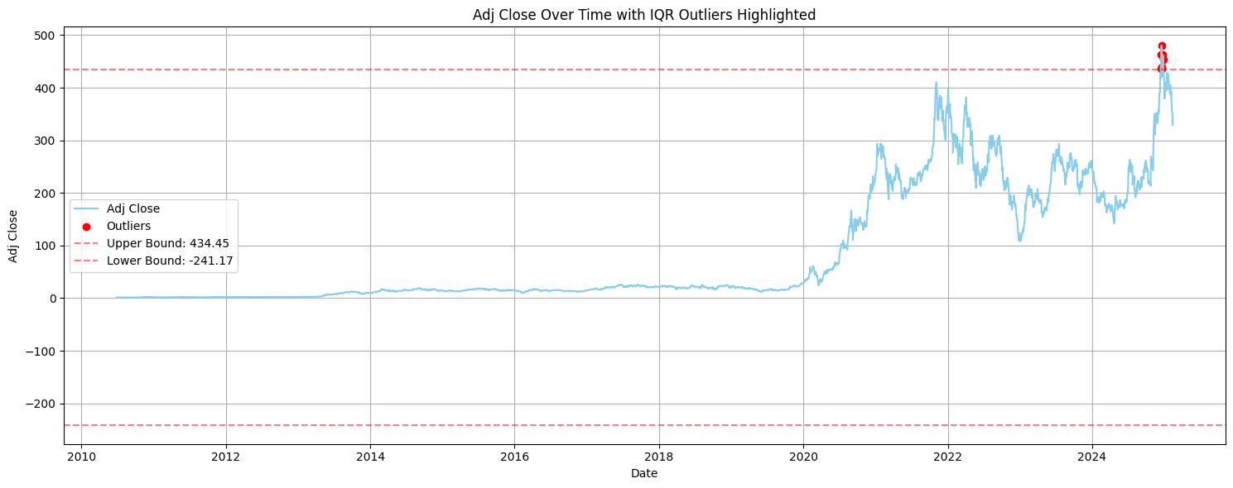

In this chart, Tesla's market valuation underwent a fundamental, explosive shift starting in late 2019, moving from a static period to sustained high growth, with specific peak periods identified as statistical outliers.

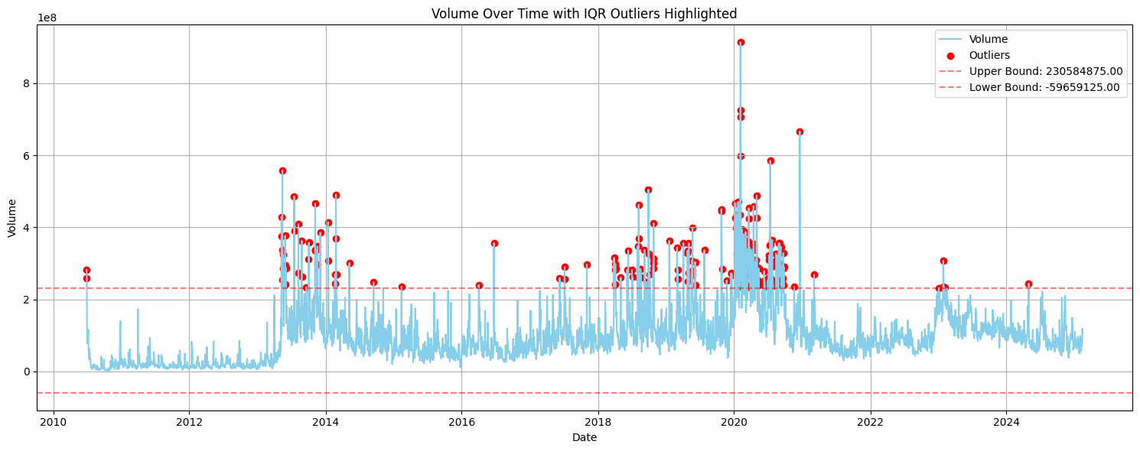

In this chart, Trading activity and market liquidity dramatically surged from late 2019, consistently remaining at significantly higher levels than early years, indicating a sustained increase in investor interest.

In this chat,the distribution of daily trading volumes fundamentally changed post-2019, showing a disproportionate number of extremely high-volume trading days that statistically stand out as outliers, indicative of a new, highly active trading environment.

**Feature Engineering**

* **Technical Indicators:**
  + Simple Moving Average (SMA_10)
  + Exponential Moving Average (EMA_10)
  + Relative Strength Index (RSI)
  + MACD, MACD Signal, MACD Diff
* **Rolling Statistics:**
  + Rolling Mean (5-day), Rolling Standard Deviation (5-day)
* **Lag Features:**
  + Previous day’s close (Close_lag1)
* **Date-Based Features:**
  + Day of the week
  + Month
* **NaN values from indicator generation were removed.**

**Model Selection Rationale**

* Problem Type: Binary Classification
* Target Variable: Will the stock go up tomorrow?

df['Target'] = (df['Close'].shift(-1) > df['Close']).astype(int)

* **Model Chosen: Random Forest Classifier**

Handles non-linear relationships

Provides interpretability through feature importance

**Training and Evaluation Results**

* Train/Test Split: 80% train, 20% test (time series - no shuffle)
* Metrics Used: Accuracy, ROC-AUC, Confusion Matrix, Classification Report

**Findings:**

* **Accuracy: ~53%**
* **ROC AUC: ~0.53**
* **Classification Report:**
  + Precision and recall scores were balanced but low, indicating weak predictive signal.
* **Confusion Matrix:**
  + Showed slight bias towards one class (whichever had more observations).

**Model Interpretation**

* Top Feature: RSI - suggests overbought/oversold signals may indicate next-day movement.
* MACD and rolling volatility features also contributed moderately.
* Date-based features were least important.
* Feature importance plot confirmed model relied heavily on technical momentum indicators.

**Model Behavior**

* Performance was slightly better than random.
* Not overfitting: No large gap between train/test performance.
* Model is conservative, detecting only strong signals.
* Likely limited by noise and lack of additional predictive inputs (e.g., sentiment).

**Conclusion**

* Technical indicators provide *some* predictive value for Tesla’s next-day movement.
* RSI and MACD were the most informative.
* The classification model was easy to interpret but not highly accurate.
* Visualization and EDA revealed Tesla’s high volatility and long-term growth trend.

**Appendix**

* Dataset Description (Open, High, Low, Close, Adj Close, Volume)
* Outlier Dates: December 2024, January 2025 (extreme price spikes)
* Outlier causes: Market news, election events (e.g., Nov 7, 2024 U.S. election)
* Charts: Feature Importance, ROC Curve, Confusion Matrix (visuals inserted separately)
* Distinct Period:

2010-2019: Period of gradual growth.

2020-2022: Period of rapid increase.

2023-2025: Period of continued high prices.